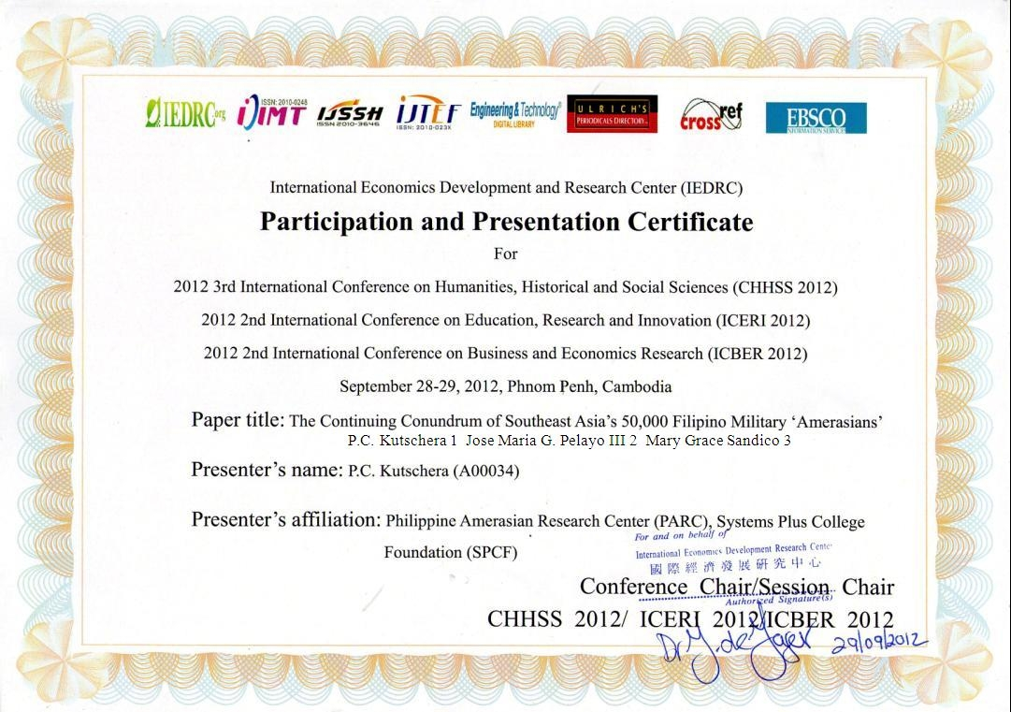

Note: The following academic research article accepted and presented at the 3rd International Conference on Humanities, History and Social Sciences 29 September 2012, Phnom Penh, Cambodia
The Continuing Conundrum of Southeast Asia’s 50,000 Filipino Military Amerasians
P.C.Kutschera 1 Jose Maria G. Pelayo III 2, and Mary Grace Talamera-Sandico 3
1 Philippine Amerasian Research Center (PARC), Systems Plus College Foundation (SPCF), Angeles City, 2009, Pampanga, Luzon, Philippines and Amerasian Research Network, Ltd., 210 Osborne Rd., Albany, NY 12205 USA, E-Mail: pkuts001@waldenu.edu or DrK@AmerasianResearch.org 2 PARC, SPCF, Angeles City, 2009, Pampanga, RP 3 College of Social Work, SPCF, Angeles City, 2009, Pampanga, RP.
Abstract. Twenty years after the withdrawal of permanent U.S. military bases from Luzon, an estimated 50,000-plus mixed heritage African, Anglo and Hispanic Amerasians - reported as infants, children and adolescents in 1992 - remain in the Philippines. Many exist under isolated, impoverished and socially marginal human circumstances. Presently into or entering adulthood, anecdotal and news media reports, coupled with a thin body of evidence-based research, uniformly report generally high occurrence of socioeconomic, psychosocial and mental health risk. Many Africans report victimization from racial stigmatization and discrimination. While many military Amerasians from neighbouring nation-states (Vietnam, Cambodia, Laos, South Korea, Thailand and Japan [Okinawa]), emigrated freely to the U.S. as refugees, special category immigrants, or due to favourable economic conditions, such advantages never accrued to Filipino Amerasians. This paper reviews current availability of empirical research on the topic. Its primary contention is that the number of Amerasians in the Philippines may be significantly larger than originally believed, actually growing in number, and discusses geo-political and military prostitution issues pertaining to Filipino Amerasians. Proposed are potential initiatives and corrective measures for social work and human services professionals, along with recommendations for renewed U.S. and East Asian-based academic research on Pan Amerasians in search for a human remedy to this conundrum.

Keywords: Filipino Amerasians, Pan Amerasians, psychosocial risk, stigmatization, military prostitution
Introduction
Two decades have passed since permanent U.S. military bases in the Philippines officially closed with the symbolic lowering of the flag at the sprawling Subic Bay naval base in Olongapo, Zambales Nov. 24, 1992. Left behind were an estimated 50,000-plus military Amerasians – mixed heritage infants, children, early adolescents and late-teens. [1,2] Military Amerasians are defined as offspring of U.S. troops, federal civilian government personnel or private military contractors, born to Filipina national mothers, and who were essentially abandoned, estranged or orphaned when these fathers left the country. [3] No official census either by the Philippine or U.S. governments has ever acknowledged the actual number of Amerasians living throughout the archipelago. However, some researchers have concluded that the original 1992 estimate was an undercount [4, 5]. Indeed, if geriatric Amerasians with roots dating back to the U.S. colonial occupation (1898-1946), second generation, and Amerasian infants and children more recently born to U.S. military personnel and military contractors training or assigned in the Philippines since the start of the Global War on Terrorism (2001-Present) are taken into account, the actual total numbers are probably much higher. [6].
Equally distressing are long-standing reports that a high number of Amerasians (e.g., particularly those of African extraction), were early and often lifelong victims of racial stigmatization and discrimination. Such conditions seemed to be universally triggered by venal name-calling, harassment and eventual bodily harm chiefly emanating from the Filipino lowlander mainstream [4].
In one of a tiny handful of empirical studies and the largest known socioeconomic study conducted among Amerasians from Philippines researchers, in 1999, over 400 respondents of all ages constituted the sample drawn from the largest military garrison towns of Olongapo (Subic Bay naval base) and Angeles City (Clark air base) where military prostitution flourished.. Other sites included Metro Manila (Sangley Point naval air station and Nichols Field), Cebu (Mactan air base) and Leyte (Tacloban air field) [7].
Filipino researchers found marked levels of stigmatization and discrimination, essentially driven by two factors: (a) the widespread belief but empirically untested hypothesis that the bulk of Amerasians were offspring of Filipina prostitutes or sex industry workers, and (b) differential physical attributes, including darker skin colour, non-conforming facial features, different hair texture and styles and odd mannerisms. These latter issues affected stigmatization of African Amerasians and made them twice the victim of discrimination according to the study. [7] Thus, with the seeds already sown many Amerasians continued to live a life filled with psychosocial risk, stigmatization and core mental health symptoms.
Filipino Amerasian Literature Review - A U.S. Perspective
Evidence-based psychosocial research on Filipino Amerasians from a U.S.-based academic perspective does not exist in the face of the U.S. military being widely regarded as the primary cause of the still ever present if not all but ignored Amerasian problem [1, 5]. In fact, a valid case could be made that U.S. academia, including many of its renowned public and private universities, has at best overlooked and at worse ignored initiation of empirical field research on Amerasians. [8] In sharp contrast, the Vietnamese Amerasian experience, a result of the Vietnam American War (1964-1975), prompted dozens of mental health field research studies. Many of these emanated from well funded U.S. government, NGO and foundational sources already covering socioeconomic and mental health issues confronting Vietnamese refugees and the well-publicized exodus of the “boat people” following the war. [9] By comparison the plight of Filipino Amerasian seldom appears in U.S. academic journals and, mostly emphasizes geo-political, ethical legal questions, and the growing isolation of island bound Pinoy Amerasians. [1, 10, 11]
Feminist research and often Amerasians themselves, when interviewed by authoritative foreign news agencies, decried the deliberate exclusion of Filipino Amerasians from U.S. immigration laws passed by Congress and signed by President Ronald Reagan in 1982 and 1987. These measures specifically excluded them from fast track access to permanent residency or citizenship, while allowing facile entry for Vietnamese, Cambodian, Laotian, South Korean and Thai Amerasians, often including their immediate families. [12, 13] While Japanese Amerasians were never included under these legislative acts, the comparatively wealthy Nippon economy has made travel, permanent residency and even U.S. citizenship a much easier road. Following 1995, three years after base closure and a time when U.S.-Philippine foreign relations had entered a period of passivity, journal articles on even these subjects of inequity and injustice dropped precipitously. EBSCO Host, Google Scholar, Sage Publications and numerous other Internet search engines following the bases aftermath period produced a mostly thin harvest of academic articles relating to Filipino Amerasians.
Aspects of Contemporary Filipino Amerasia
Anecdotal and news media sources have long reported socioeconomic and psychosocial crises for Filipino Amerasians, particularly in the proverbial Angeles City-Manila- Olongapo “Amerasian triangle.” [4] Located in west central Luzon, it was the site of most U.S. bases, installations and forces during the Cold War (1948-1990). Today, the triangle probably contains the highest concentrations of military born Amerasians in the Western Pacific Basin, in large measure due to the highly restrictive U.S. State Department and U.S. Embassy emigration policies and procedures confronting Amerasians seeking a homecoming to their father’s domicile.
One of the only known contemporary U.S.-based human psychosocial risk and mental health studies on Filipino Amerasians occurred from 2007 to 2010 with a small population residing inside the Amerasian triangle. The study was a doctoral dissertation published in 2011. [4] Employing mixed qualitative and quantitative methodology similar to numerous studies on Vietnamese Amerasians in the 1980s and 1990s [9, 14, 15], this research focused on the impact of stigmatization and discrimination related psychosocial risk and stress and their relationship to core mental health symptomatology (depression, anxiety and stress). Conducted with the cooperation of the Sacramento, California, U.S.-based Philippine Children’s Fund and the Pearl S. Buck Foundation in Manila, a total of 16 African and Anglo Amerasians from Angeles City were purposively sampled for the research. Two bi-racially equal age groups (late adolescents and young adults), ranging from ages 16-to-39 included equal numbers of females and males. In-depth interviews provided descriptions of how their life experiences influenced their mental health. [4] After the interviews ended, the sample completed the Australian developed DASS 21 (Depression Anxiety Stress Scales-21) measurement inventory. [16]
The Results
Qualitative cross-case analysis revealed multiple psychosocial risk factors, including alcohol and drug abuse, poverty and homelessness. Many factors were stigma-related, including exposure to biracial tension and violence, name-calling, abandonment despair, identity confusion and derivative family strain, low self-esteem and social isolation. More than half the sample (62.5%) scored severe levels of anxiety, depression or stress on the DASS-21. [4] Over half the study’s respondents (57%) reported numerous psychosomatic complaints or suspected somatization disorder. [4]
Social change implications included the need for more emphasis by the U.S. Department of Defence (DOD) on preventing negative consequences for local inhabitants and their children. The recommendations were for the DOD to better manage troop personal leave and rest and recuperation habits, particularly monitoring private contractor employees who often accompany military deployments abroad.
The Study’s Recommendations
1. Easing U.S. immigration restrictions for land bound Filipino Amerasians and a call for new social services interventions and jobs development programs, possibly by the U.S. State Department’s Agency for International Development and cooperatively with the Philippine government and other U.S. American based NGOs, NGAs, foundations and not-for-profits. [4]
2. Reawakening U.S. academic social science research on the issue of Pan Amerasians, and chiefly Filipino Amerasians facing a myriad of psychosocial, economic and environmental problems. [4]
3. Developing research with larger samples and more dispersed study locations, needed to comprehensively study the mental health status and socioeconomic conditions of military Amerasian progeny throughout the archipelago. Exploring the high incidence of psychosomatic complaints or illness, origins and effective treatment options. [4]
4. Availing the findings to social services groups serving Amerasians, a recommendation made by Dr. Carolyn I. Sobritchea, renowned University of the Philippines-Diliman anthropologist, who co-authored the large 1999 UP-Diliman Women’s Studies Department quantitative research study on Filipino Amerasians. [7] The educator praised this latest research as a “pioneering effort…describing and analyzing the state of emotional and mental health of our Filipino Amerasians.” In addition to being “revealing and valuable,” Dr. Sobritchea urged that the U.S. Amerasian research be “widely disseminated especially to organizations working directly with this sector in (Philippine) society.” [17]
The Story Continues Unchanged
As the Philippines approaches the 20th of anniversary of the emblematic departure of U.S. troops from Subic Bay in November, 2012 , the daily realities of Amerasians in Olongapo and Angeles City.have not changed. [18] “Everywhere you look you can still see them – Black, White, all kinds,” an Amerasian mother of three second generation Amerasians residing in Olongapo observed. [18] Since the 1999 approval of the Philippine-U.S. Visiting Forces Agreement (VFA), U.S. naval vessels are again using Subic Bay for refuelling and maintenance visits and former Clark air base for joint training exercises . “They should stop sending those US ships here because of the VFA. If the Americans can’t take care of their responsibilities to their children, then they should stay out of here. It’s impossible for them to b e here without adding (to the numbers of Amerasians),” the Amerasian mother asserted. [18]
Indeed, occasional TV, radio and Internet news media and anecdotal reports continue in and out of Manila, central Luzon, the Visayas, and Mindanao about new U.S. military service member and defence contractors siring Amerasian babies, and children being born to Filipina national mothers. Some of these fresh generation Amerasians relive the ongoing narrative of being abandoned, neglected, or not supported by their fathers. [6] While not anywhere near the level of the Vietnam and post-Vietnam American War era heyday of military supported prostitution surrounding bases and installations, these new Amerasians are nevertheless being born primarily from military personnel fraternization with Filipina national women from three ongoing, feeder sources:
- Joint U.S.- Philippine Balikitan military exercises conducted annually in Central Luzon at the former Clark air base, Crow Valley bombing range, Tarlac, and Fort Magsaysay, Neuva Ecija. [6]
- Continuing U.S. military operations supporting the Philippine armed forces role in the U.S. War on Terrorism involving suspected Muslim subversives and al-Quaeda and Abu Sayyaf operatives in southwest Mindanao. [6]
- Filipina sex industry entertainers who are impregnated by U.S. military contractors and servicemen at clubs and juice bars surrounding U.S. bases in Japan (Okinawa), South Korea, and the U.S. Territory of Guam, and return home before or immediately following their baby deliveries. [6]
Final Recommendations and Conclusions
The imperative is for new, evidence-based academic research on socioeconomic, psychosocial and mental health issues facing Filipino and secondarily Pan Amerasians. Many issues reported among Filipino Amerasians continue to be similar in character to those found in refugee, displaced person and disrupted immigrant populations. [4, 19] Consistently, researchers familiar with these traumatized populations, many of whom exhibit psychosocial stressors including homelessness and housing insecurity, racial or national identity crisis, social isolation and impoverishment, say such populations are apt to eventually lose resiliency and put them at risk for mental or physical health impairments. [19]
These realities, coupled with the understanding that the U.S. government to date has not become aggressively involved in offering serious immigration relief for impoverished Filipino Amerasians, presents a great challenge for the field of international social work and social welfare services. Professional U.S. social workers and social welfare services workers have toiled periodically on a project basis with the United Nations High Commissioner for Refugees (UNHCR), World Health Organization (WHO) and Children’s Fund (UNICEF). A handful of international NGOs such as International Social Service, have a robust U.S. social work component. [20]
Social work has historically been involved in counselling refugees and addressing their psychological issues. [19, 20] In addition to their roles as mental health counsellors, social workers can serve as case managers and problem-solvers for refugees, or related populations such as Filipino Amerasians. They can use basic skills of matching needs and services to meeting essential human needs of alleviating psychosocial risk and stress factors identified in studies of Vietnamese, Filipino Amerasians, and other Pan Amerasian populations. Professional challenges and opportunities remain and await creative leadership to address these vital issues.
Acknowledgements
Professor Marie A. Caputi, Ph.D., Walden University, Minneapolis, MN, USA; Dr. Carolyn I. Sobritchea, Ph.D., Dean, Asian Center, University of the Philippines-Diliman, Quezon City, RP and Dr. Paulo O.J. Fuller, Ph.D., Dean, College of Social Work and Director, Centre for Social Research, SPCF, Angeles City 2009, Pampanga, RP, for their continuing support of this research and voluntary expertise.
References
[1] R. Levi. Legacies of War: The United States’ Obligation toward Amerasians. Stanford Journal of International Law, 1993, 29(2): 459-502.
[2] S. Sturdevant & B. Stoltzfus. Let the Good Times Roll: Prostitution and the U.S. Military in Asia. New York: The New Press, 1992.
[3] Amerasian Definition. Amerasian Foundation website. 2012. Retrieved from http://amerasianfoundation.org/amerasian-definition/
[4] P. Kutschera. Stigmatization, Psychosocial Risk and Mental Health Symptomatology among Amerasians in the Philippines: A Multiple-Case Study. (Doctoral dissertation, College of Social and Behavioural Sciences, Walden University). 2010, pp. 37-39. Retrieved from: www.AmerasianResearch.org/dissertation and www.AmerasianResearch.org/abstract
[5] C. Enloe. Bananas, Beaches and Bases: Making Feminist Sense of International Politics. Berkeley, CA, USA: University of California Press, 1989.
[6] P. Kutschera, M.G. Talamera-Sandico. The Derivative Family Construct among Filipino Amerasians in Luzon. Paper presented at the Forum on Cross-Cultural Identities (Narratives of Resistance and Adaptation), Asian Center, University of the Philippines-Diliman. 2012. Retrieved from www.AmerasianReserch,org/derivative
[7] C. Gastardo-Conaco, C. Sobritchea. Filipino-Amerasians: Living in the Margins. Quezon City, RP: University of the Philippines Center for Women’s Studies Foundation & Pearl S. Buck International. 1999.
[8] National Amerasian Research Institute. Filipino Amerasians Short Changed by U.S. Academia Mental Health Lecturer tells University of the Philippines Asian Center Cross Identities Forum. [Press Release]. 2012, February 24, Retrieved from www.AmerasianInstitute.org
[9] R. McKelvey. The Dust of Life: America’s Children Abandoned in Vietnam. Seattle, WA, USA: University of Washington Press. 1999.
[10] K. Montes. U.S. Recognition of its Obligations to Filipino Amerasians Under International Law. Hastings Law Journal, 1995, 46(6): 1621-1631.
[11] J. Ahearn. Out of Sight, Out of Mind: U.S. Immigration Law and Policy as Applied to Filipino-Amerasians. Pacific Rim Law and Policy Journal, 1993, 105.
[12] K. Maclear. Drawing Dividing Lines: An Analysis of Discursive Representations of Amerasian “Occupation Babies.” Resources for Feminist Research Journal, 1995, 23(4): 20-33.
[13] A. Easton. U.S. Navy Bases Cloud Subic New Dawn: The Prospects for the Discarded Children of Olongapo City. The Guardian Newspaper (U.K.) 1997, July 22, pg. 014.
[14] J. Felsman, M. Johnson, M. Leong, I. Felsman. Vietnam Amerasians: Practical Implications of Current Research. Washington, DC: Office of Refugee Resettlement, 1989.
[15] F. Bemak, R. Chung. Vietnamese Amerasians: Psychosocial Adjustment and Psychotherapy. Journal of Multicultural Counselling & Development, 1997, 25(1), pp. 79-88.
[16] S. Lovibond, P. Lovibond. DASS Manual for Depression Anxiety Stress Scales (2nd ed.). Sydney, Australia: Psychology Foundation, 1995.
[17] National Amerasian Research Institute. U.S. Amerasian Research in Angeles City Comprises ‘A Pioneering Effort’ Says UP-Diliman Asian Center Professor. [Press Release]. 2011, June 15, Retrieved from www.AmerasianResearch.org
[18] R. Gonzaga. Amerasians Still Yearn for Recognition. Philippine Inquirer (R.P.) 2011, January 11.
[19] M. Potocky-Tripodi. Best Practices for Social Workers with Refugees & Immigrants. New York: Columbia University Press, 2002.
[20] M.Hokenstad, J. Midgley. Realities of Global Interdependence: Challenges for Social Work in a New Century. In M. Hokenstad, J. Midgley (eds.). Issues in International Social Work. Washington, DC: National Association of Social Workers Press, 1997.
American Psychological Association (APA) 6th Ed. Citation
Kutschera, P.C., Pelayo, J.M.G. III & Talamera-Sandico, M.G. (2012, September) The continuing conundrum of Southeast Asia’s 50,000 military Filipino Amerasians. Paper presented at the 3rd International Conference on the Humanities, History and Social Sciences (CHHSS-2012). Phnom Penh, Cambodia. Retrieved from www.AmerasianResearch.org/conundrum

